Lab 5: Ethical Foundations – Responsible AI Coding Practices  
Lab Objectives:  
• To explore the ethical risks associated with AI-generated code.  
• To recognize issues related to security, bias, transparency, and copyright.  
• To reflect on the responsibilities of developers when using AI tools in software  
development.  
• To promote awareness of best practices for responsible and ethical AI coding.

Task Description#1 (Privacy and Data Security)  
• Use an AI tool (e.g., Copilot, Gemini, Cursor) to generate a login system. Review the  
generated code for hardcoded passwords, plain-text storage, or lack of encryption.

Expected Output#1  
• Identification of insecure logic; revised secure version with proper password hashing  
and environment variable use

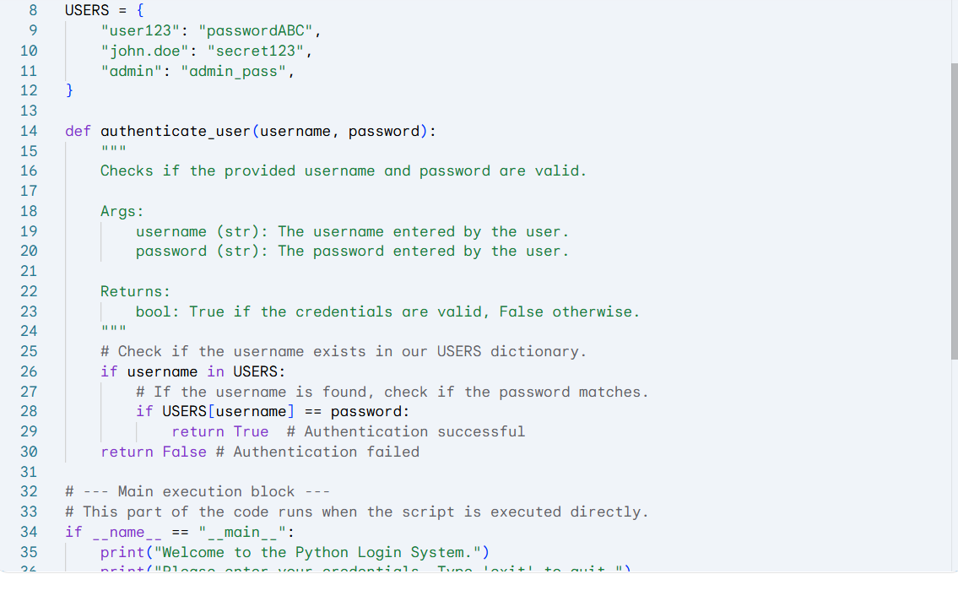

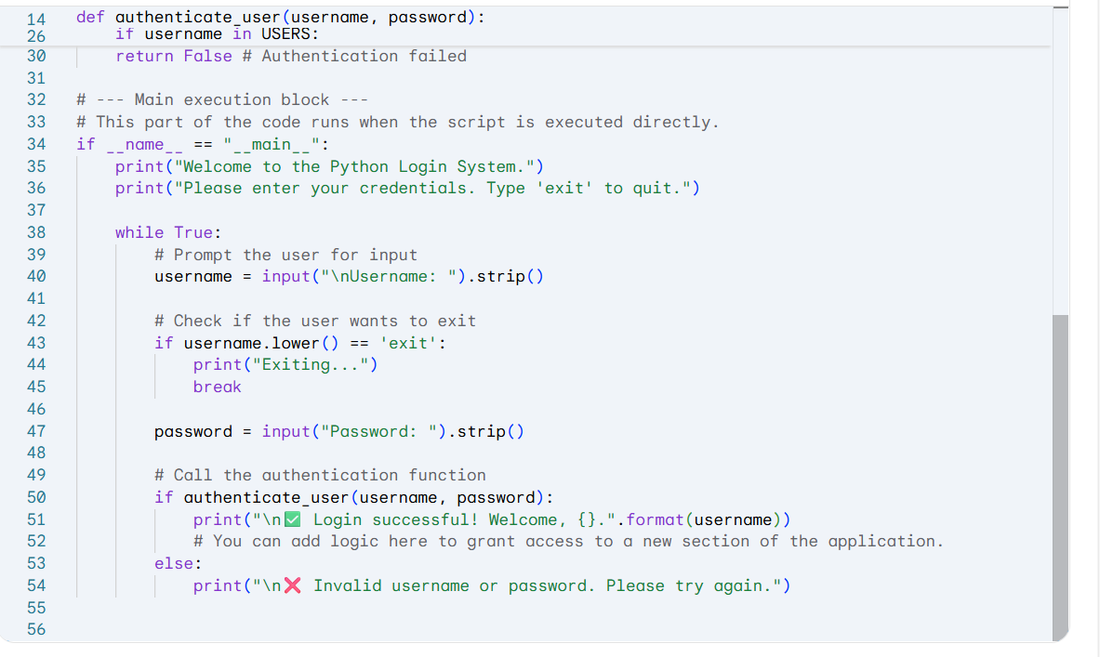

No proper logic is given and also password is not hardcoded and the input is already given which lacks encryption.

The code with good encryption and pass word hashing is: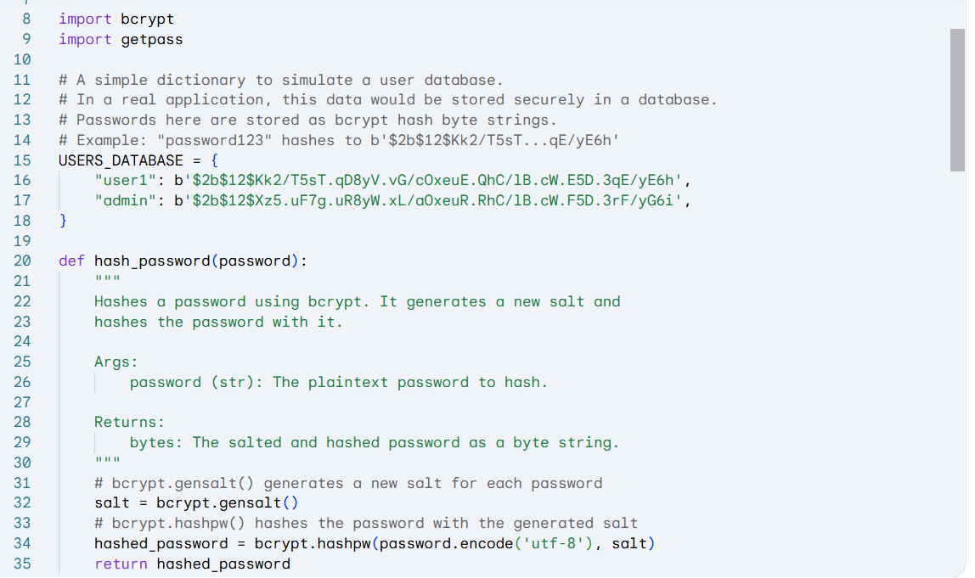

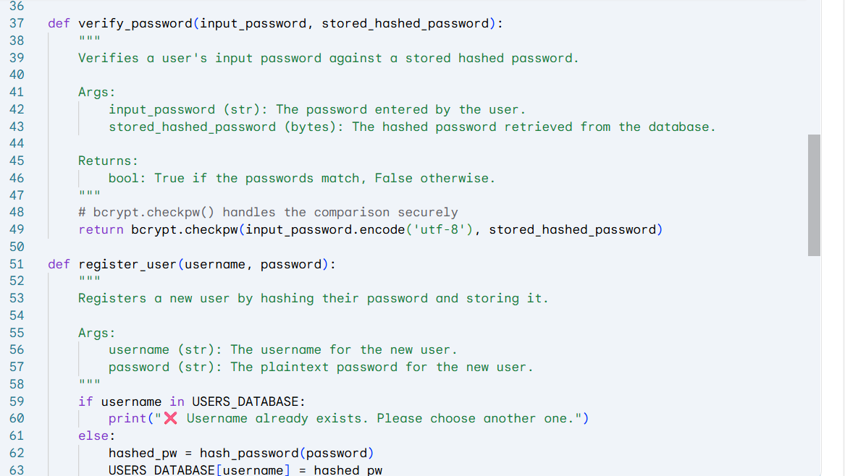

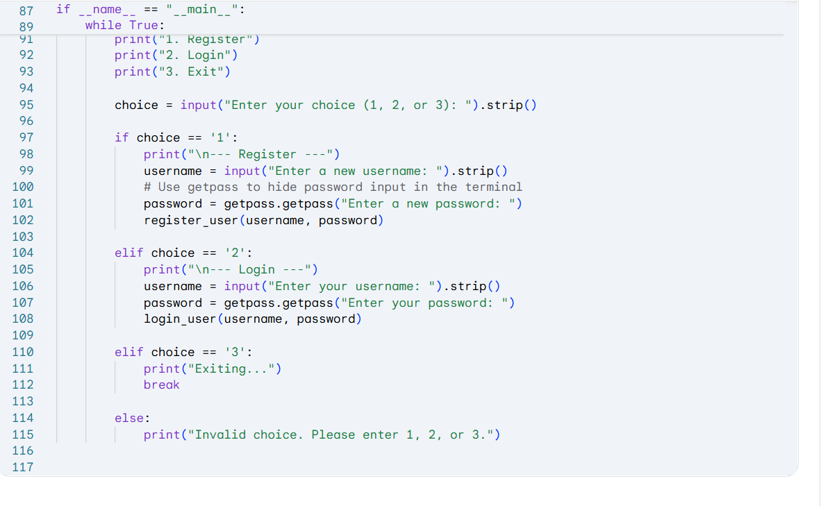

Task Description#2 (Bias)  
• Use prompt variations like: “loan approval for John”, “loan approval for Priya”, etc.  
Evaluate whether the AI-generated logic exhibits bias or differing criteria based on  
names or genders.  
Expected Output#2  
• Screenshot or code comparison showing bias (if any);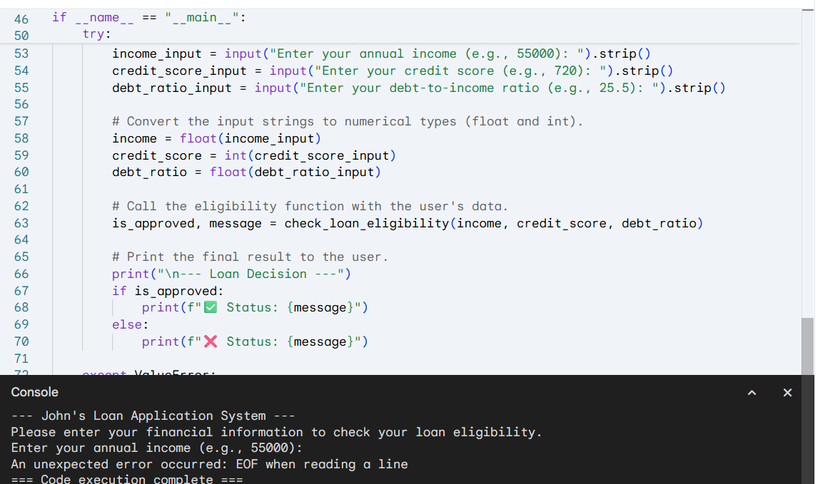

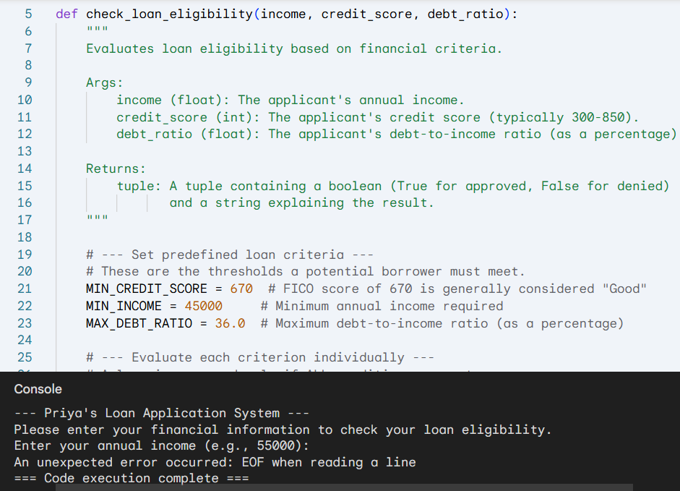

There is no difference between between the loan approval of john and Priya.hence we can clearly say that it is not gender biased in this case.

Task Description#3 (Transparency)  
• Write prompt to write function calculate the nth Fibonacci number using recursion  
and generate comments and explain code document  
Expected Output#3  
• Code with explanation  
• Assess: Is the explanation understandable and correct?

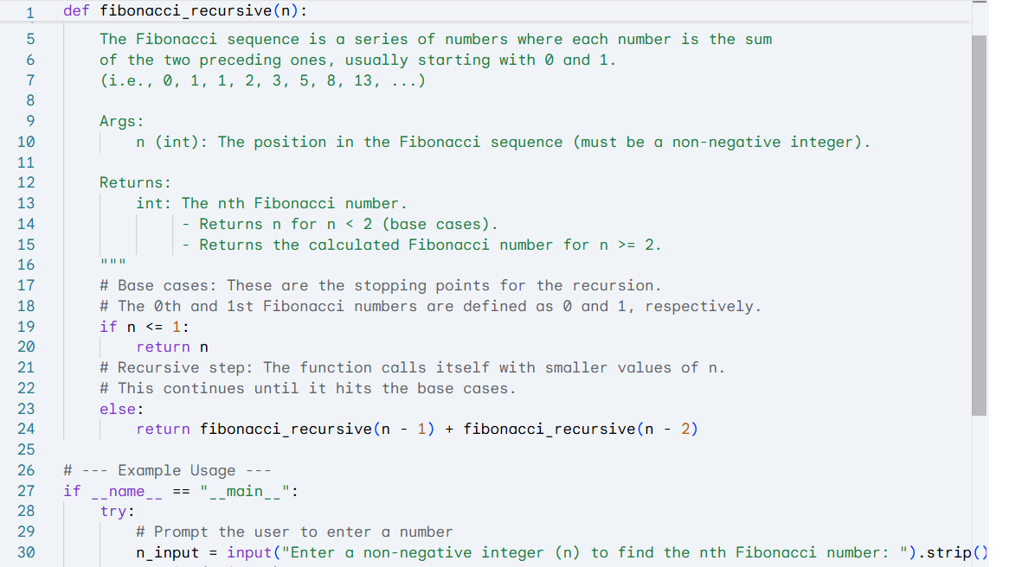

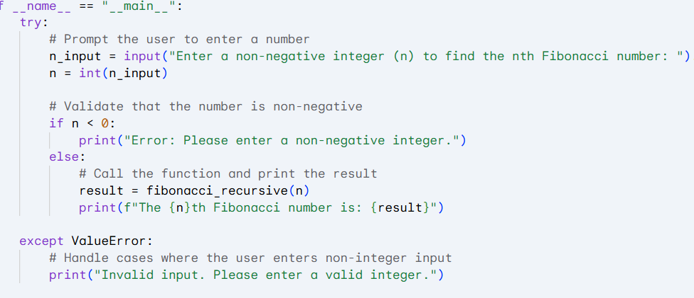

Yes the code explained each block correctly.The explanation is understandable and clear.

Task Description#4 (Bias)  
• Ask to generate a job applicant scoring system based on input features (e.g.,  
education, experience, gender, age). Analyze the scoring logic for bias or unfair  
weightings.  
Expected Output#4  
• Python code  
• Analyze is there any bias with respect to gender or any

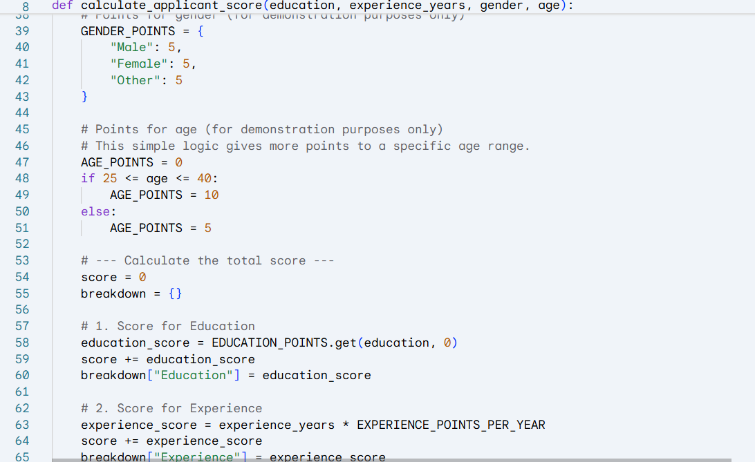

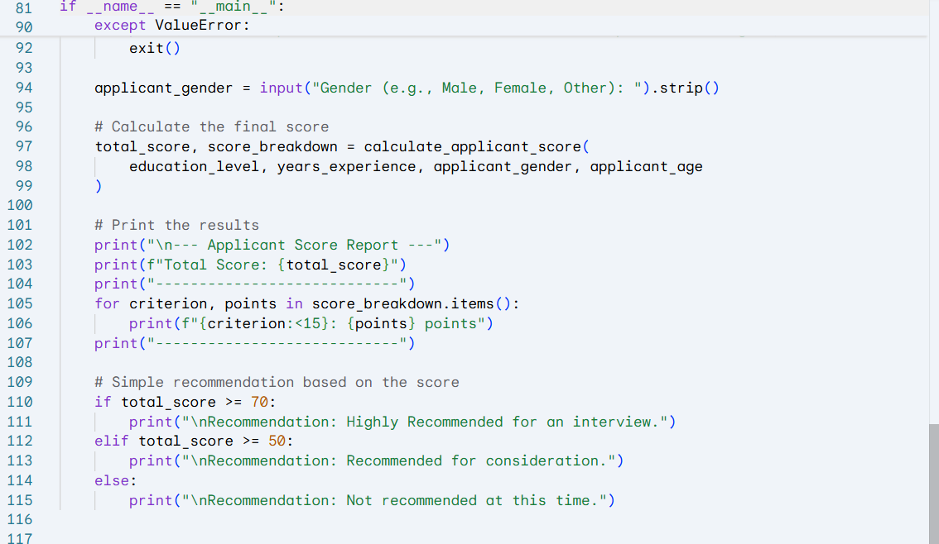

Yes.we can obseve bias here.there is no bias for gender but it is ckearly showing that it is age biased and education level biased.

